1,

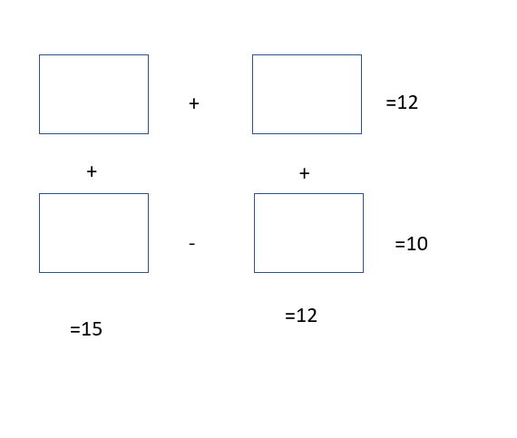

12.5

2.5

9.5

2.5

2,

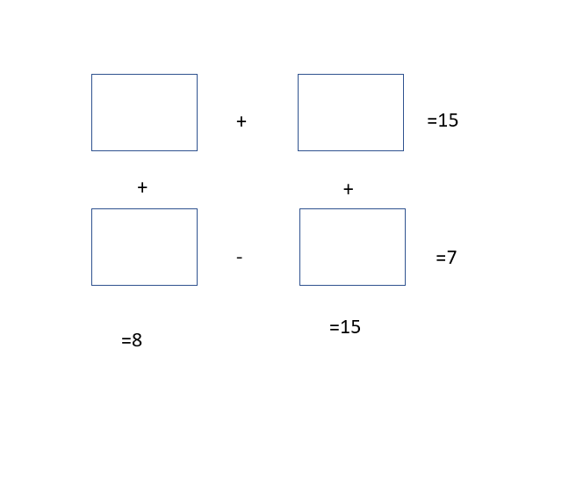

14.5

7.5

0.5

0.5

3,

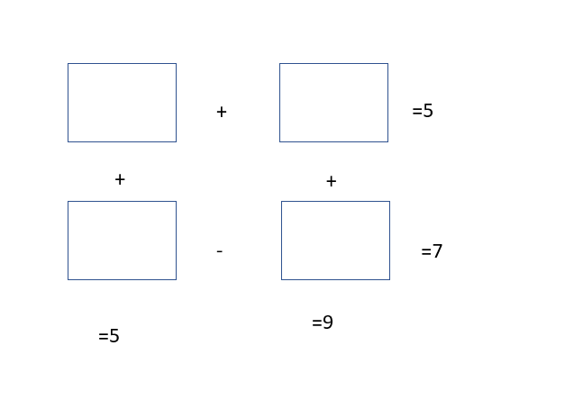

-3

8

1

8

4,  
1 , 2 , 4 , 8 , 16, 32, 64.  
1, 4 , 16 , 64, 256,1024.